**Module 8: Portfolio Project: Project Code and GitHub Link**

Carley Rizzo

Colorado State University Global

MIS581: Capstone – Business Intelligence and Data Analytics

Dr. Lisa Bryan

December 4, 2022

**Module 8: Portfolio Project: Project Code and GitHub Link**

The following pages will include the programming code and data analysis outcomes to the statistical tests conducted within SAS Studio for the Capstone Project. Each screenshot represents a statistical test outcome, the first six figures visualize the paired t-test results and the final five figures visualize the ANOVA testing results. Directly below is the link to a Github account, where all elements of the Capstone Project have been uploaded in supplement to this word document.

The Github link:

<https://github.com/rizzocarley/Capstone-Project>

**Figure 1**

*Paired T-Test Unbonded Cap Results*

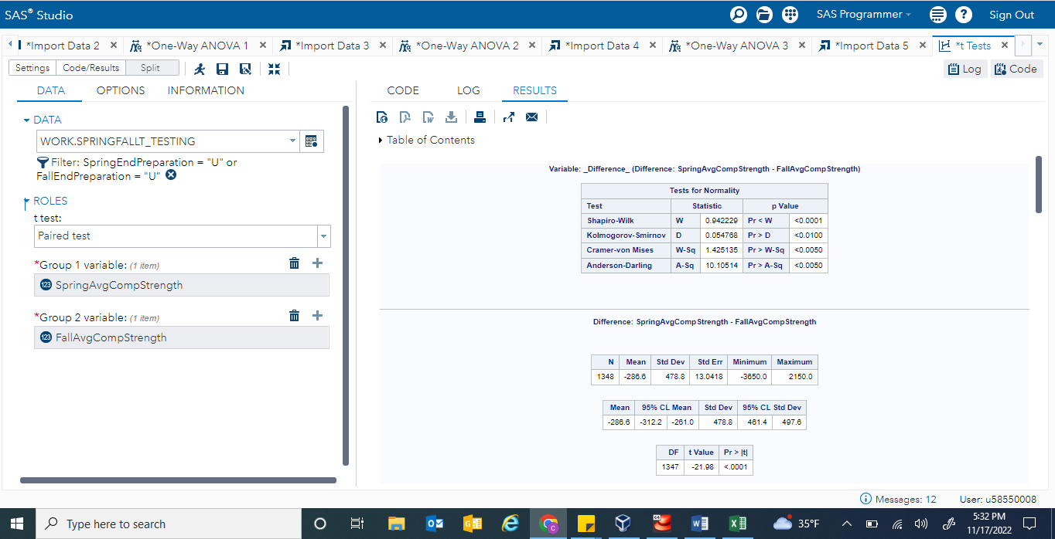

Note. Located above is the T-Test function output within SAS Studio for the unbonded cap method. The left side displays the data input, and the right side illustrates the results. These results were plugged into a manual table generated for the research project.

**Figure 2**

*Paired T-Test Sulfur Capping Results*

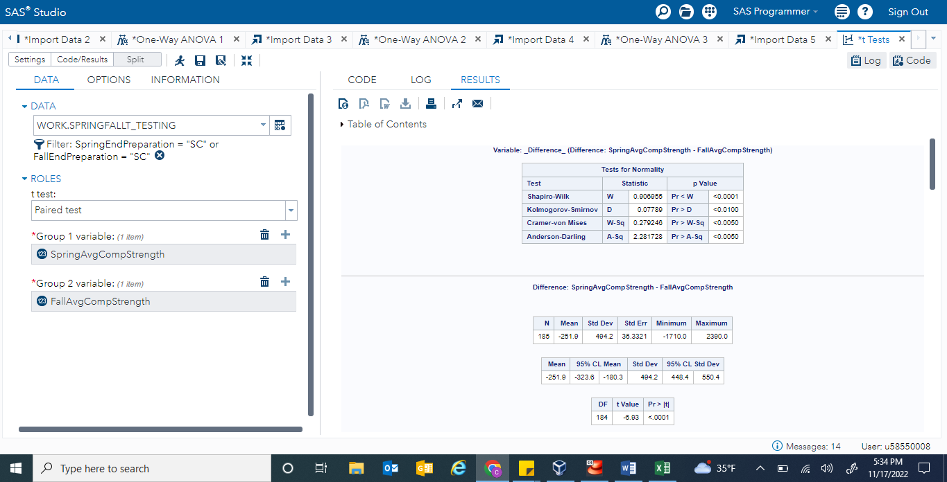

Note. Located above is the T-Test function output within SAS Studio for the sulfur capping method. The left side displays the data input, and the right side illustrates the results. These results were plugged into a manual table generated for the research project.

**Figure 3**

*Paired T-Test Gypsum Capping Results*

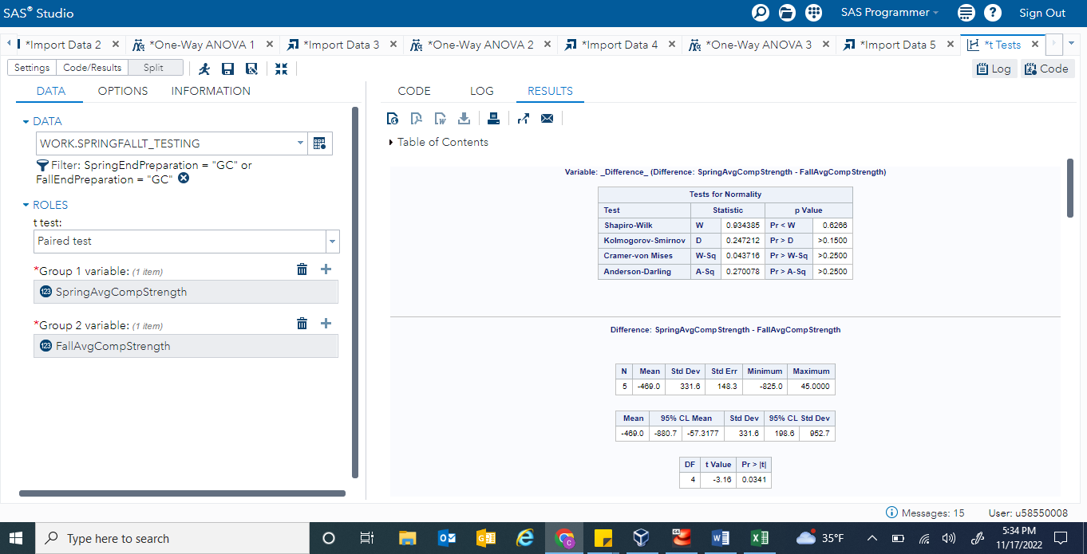

Note. Located above is the T-Test function output within SAS Studio for the gypsum capping method. The left side displays the data input, and the right side illustrates the results. These results were plugged into a manual table generated for the research project.

**Figure 4**

*Paired T-Test Grinding Cylinder End Results*

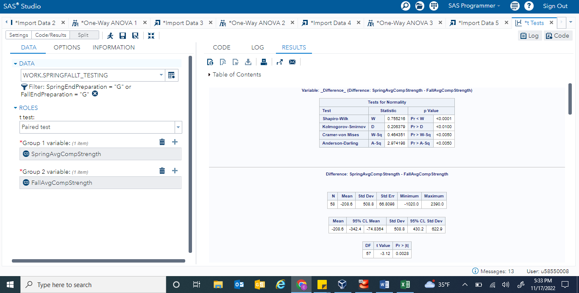

Note. Located above is the T-Test function output within SAS Studio for the grinding cylinder end method. The left side displays the data input, and the right side illustrates the results. These results were plugged into a manual table generated for the research project.

**Figure 5**

*Paired T-Test Collective Spring and Fall Sample Results*

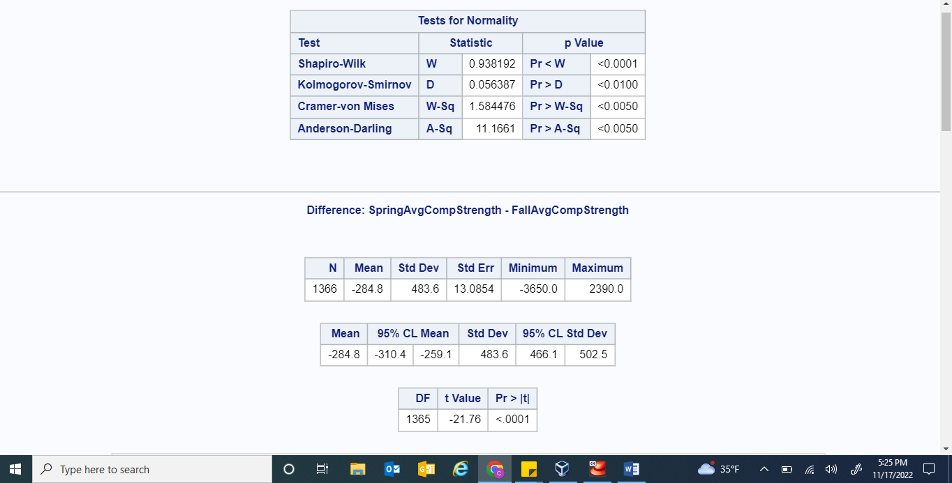

Note. Located above is the T-Test function output within SAS Studio for the collective spring and fall samples. The input data for this result generation is exactly like the inputs in the previous four Figures, except there is no filter applied on the either the spring or the fall samples. This ensures the software considers every datapoint within the assessed columns. These above results were plugged into a manual table generated for the research project.

**Figure 6**

*Graph of Paired T-Test Results from the Collective Spring and Fall Samples*

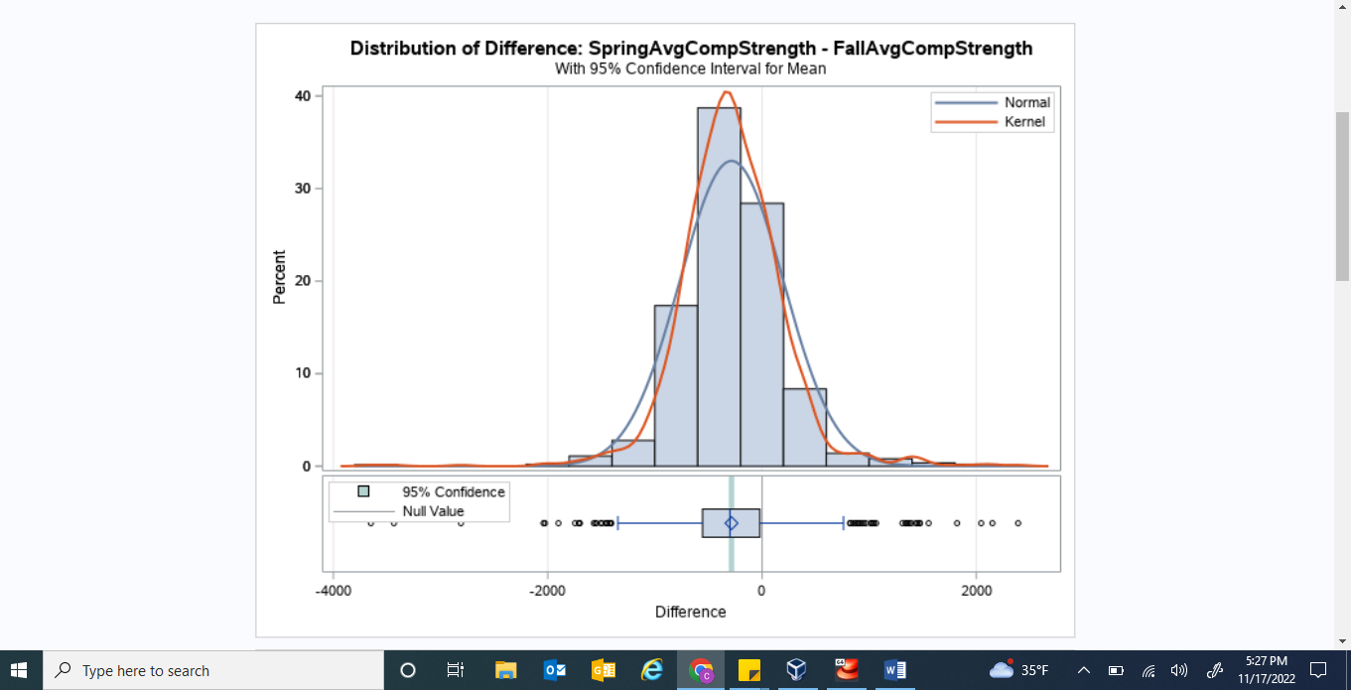

Note. Located above is the graphical output generated in addition to the output from Figure 5 above. This graph was used within the research project to visualize the normal distribution of the datasets, and validate the paired t-test results.

**Figure 7**

*ANOVA Test Spring 4x8 Sample Results*

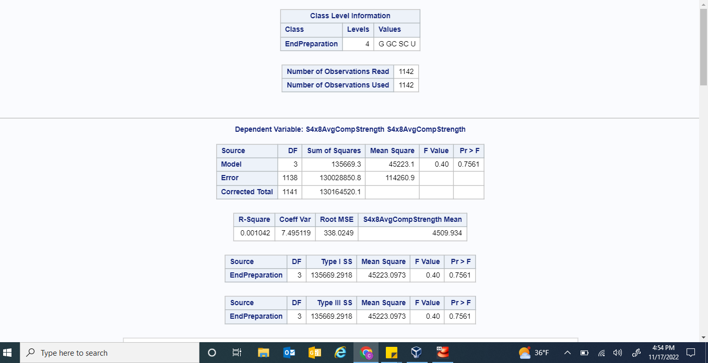

Note. Located above are the results from inserting the spring 4x8 sample dataset into the ANOVA testing function of SAS Studio. The dependent variable was set to the compressive strength value and the categorical variable was set to the end preparation method. The returned p-value above was plugged into a manual table generated for the research project.

**Figure 8**

*ANOVA Test Spring 6x12 Sample Results*

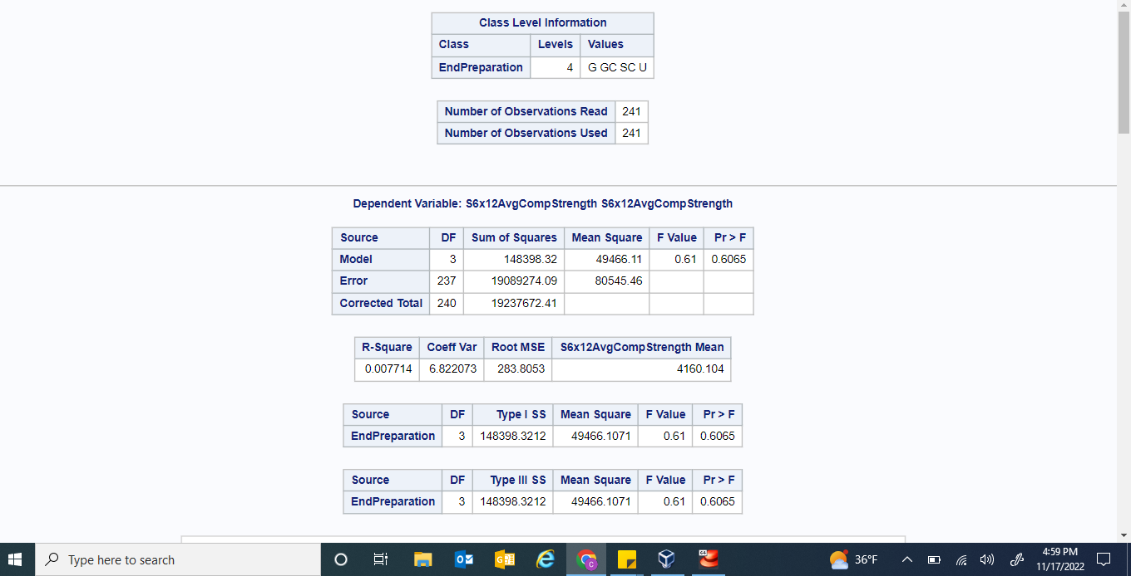

Note. Located above are the results from inserting the spring 6x12 sample dataset into the ANOVA testing function of SAS Studio. The dependent variable was set to the compressive strength value and the categorical variable was set to the end preparation method. The returned p-value above was plugged into a manual table generated for the research project.

**Figure 9**

*ANOVA Test Fall 4x8 Sample Results*

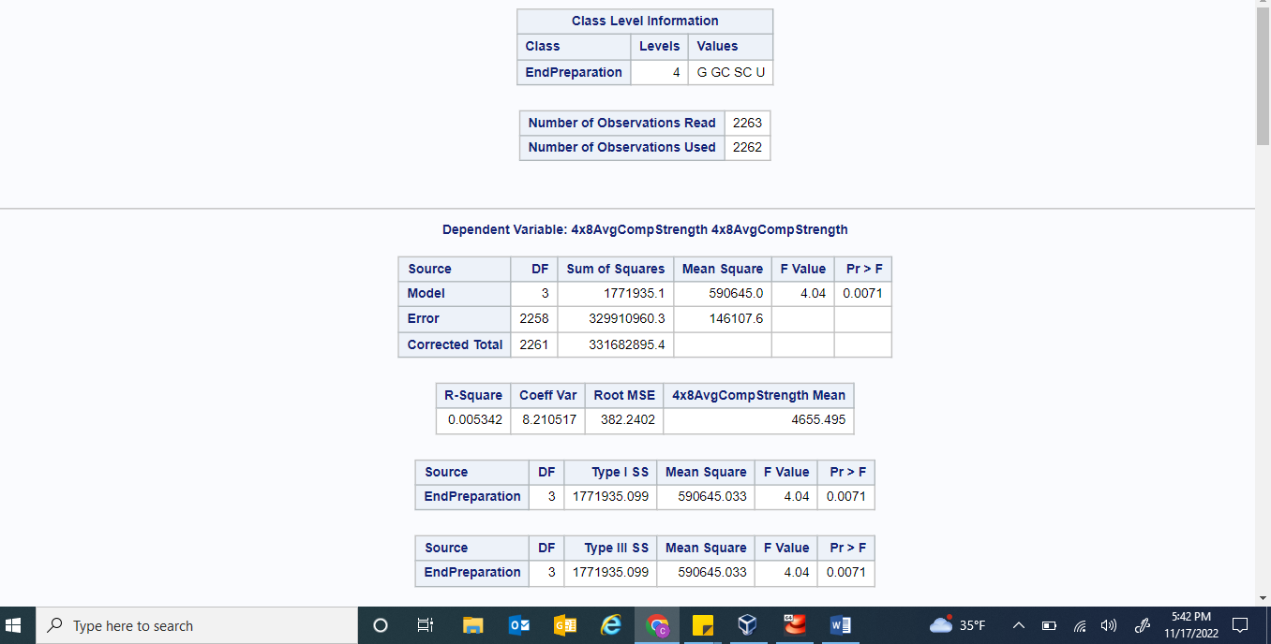

Note. Located above are the results from inserting the fall 4x8 sample dataset into the ANOVA testing function of SAS Studio. The dependent variable was set to the compressive strength value and the categorical variable was set to the end preparation method. The returned p-value above was plugged into a manual table generated for the research project.

**Figure 10**

*ANOVA Test Fall 6x12 Sample Results*

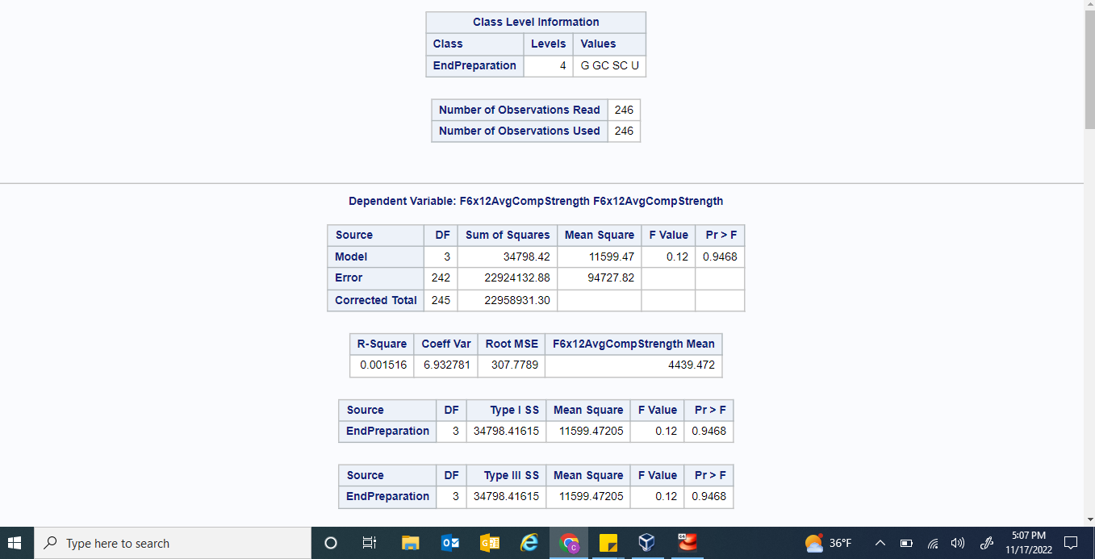

Note. Located above are the results from inserting the fall 6x12 sample dataset into the ANOVA testing function of SAS Studio. The dependent variable was set to the compressive strength value and the categorical variable was set to the end preparation method. The returned p-value above was plugged into a manual table generated for the research project.

**Figure 11**

*ANOVA Test Fall 4x8 Graph of Results*

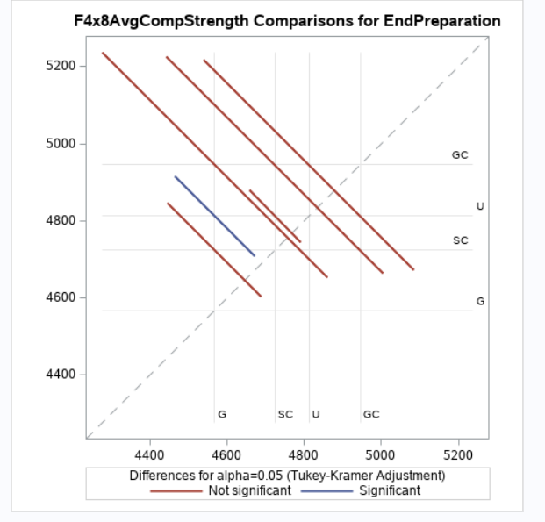

Note. Located above is the graphical output from inserting the fall 4x8 sample dataset into the ANOVA testing function of SAS Studio. Since this sample returned a statistically significant p-value, as seen in Figure 9 above, this graph was examined and included within the research project to visualize the reasoning behind the p-value.